# **COMP-1701 - Transferring Data to Databases**

## **Data Science & Machine Learning (DSML) - RRC Polytech**

Module A.2 - Database Server - Verification and Configurations

So, the install is complete!! Now you need to understand what just happened to your computer, here you will learn:

Task Manager / Activity Monitor

These OS utilities provide you with sufficient information on how to manage your computer and determine the status of our database installation.

On a Mac, it is called **Activity Monitor**

There are many ways to open it:

Windows > Task Manager

1. (**RIGHT**-click) on Taskbar, choose Task Manager in popup menu  
     
   …or…
2. [**CTRL**]-[**ALT**]-[**DEL**] and (**CLICK**) on Task Manager
3. (**CLICK**) on [**START**] menu > Windows System > Task Manager
4. (**RIGHT**-click) on [**START**] menu and in popup, (**CLICK**) on Task Manager
5. [**START**] and type in Task Manager, then hit [**ENTER**]

Understanding The Database Service

Within Task Manager / Activity Monitor > Processes > Name or Process Name, look for "**mysqld.exe**"

Click on the *Name* or *Process Name* column to sort the processes in alphabetical order.

As you can see, the **mysqld.exe** service be showing the **CPU** at **0%** and **Memory** at **<1%** so it is currently not using much resources.

When you collapse the **mysqld.exe** process, you will see **MariaDB**, which is the Service it is being run as.

(**RIGHT**-click) on MariaDB, and from the popup, select Open Services

(**CLICK**) on any of the Services listed in the Services window, and type Maria, and this will quick nav you to the actual MariaDB Service, which after install is always Running in the background, thus making the databases accessible.

(**DOUBLE**-click) to open the **MariaDB** Service to see its configuration or (**RIGHT**-click) and select **Properties**

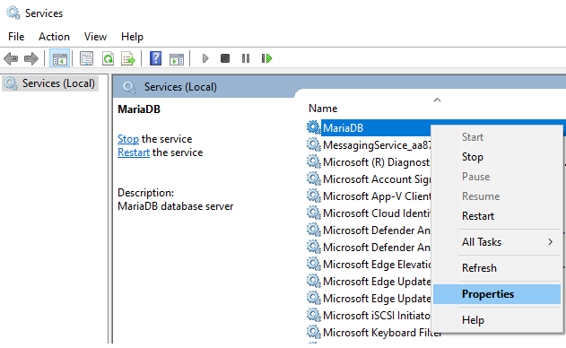

MariaDB Service settings:

Startup Type is set to "Automatic"

* means that when you start up and shutdown your computer, it will safely ***start and shutdown the MariaDB service***
* following this course, if you aren't developing with MariaDB at some point in the future, you can set the Service to **Manual**, on your computer, so it isn't using any additional computer resources
* if you ever need to **restart your MariaDB service**, you need to do it here, and we **will need to do this when applying configurations** that vary from the installed default database server's settings

Path to executable:

"C:\Program Files\MariaDB 10.10\bin\mysqld.exe" "--defaults-file=D:\_DATA\MariaDB\data\my.ini" "MariaDB"

This is all in one line, it's a command-line request, and we need to dissect it a bit...

C:\Program Files\MariaDB 10.10

is the install directory where MariaDB version 10.10 is installed, copy that path and paste it in File Explorer, and you will see the next part of the command-line:

\bin

* directory that contains various command-line tools (executables/binaries) for data activities (backups, imports, exports, conversions) and other database management activities (upgrades)
* contains the **mysql.exe** **CLI** (**Command-Line Interface**) used to work in **MariaDB** in a command line prompt or terminal session
* contains various storage engine type binaries and "**mariadb*.exe**" to "**mysql*.exe**" where the * in many cases are the same function with **MariaDB** has its own mods to the MySQL binaries, though includes those binaries as well in the **/bin** dir
* and also contains various mysql/mariadb utilities.

\mysqld.exe ... "MariaDB"

* this is "**MariaDB**" Service being ran in the background (that we have just accessed to view its Service settings…and saw in the Task Manager)

--default-file=

* is a parameter that is applied when the mysqld.exe MariaDB Service is started up, that is pointing to:

D:\_DATA\MariaDB\data

* is the directory where all databases are stored, known as the **Data Directory** or **DATADIR**
* ***copy*** *your path to your* ***File Explorer****, and paste in the* ***address bar***

* contains initial administrative databases that MariaDB/MySQL needs to store and will also store the information on the databases you will be creating, in other words:

*Your database's structure is stored in a database. Makes sense?*

* the listing contains files that include your *computername*, with:
* **.err** (for error messages, handy when working on your assignments, opens in text editors) and
* **.pid** (relates to the PID that your MariaDB service is running on, see Task Manager, all running files on your computer have a PID number, on either Windows or Mac)
* and also contains the primary configurator, the **my.ini** or **my.cnf** file…depends on OS you use where **.cnf** is Linux(Mac) config file.

\my.ini

* is the configuration file with default settings when the database server is installed, these are stored in my.ini on Windows and my.cnf on Mac/Linux
* always make a backup of the file, before editing the file (more on this to follow)

Activity:

* copy your filepath, mine is:   
    
  **D:\_DATA\MariaDB\data\my.ini**
* open **Notepad++** and choose **File** > **Open**
* under **File Name** text box, paste in **filepath** [**ENTER**] to open it

Notice:

* lists section headers for database service [**mysqld**] and connecting [**client**] computers/servers

* indicates location where the databases are stored, which happened during the install, datadir (DATADIR),
* and any other install specific configurations made during the install, such as the:
* **Port** (port=): **3306**, is the default, and used for the network connection to the database (w/IP Address, Username, Password)
* **InnoDB Buffer Pool Size** (innodb_buffer_pool_size=):
* **InnoDB** is the storage engine that is commonly used for websites, which locks tables at the row level (vs. **MyISAM** which locks at the table level)
* **Buffer Pool Size** calculates the Total RAM of your computer, then divides it by 8, so for my computer it is 16 GB/8 works out to **2037 MB** (so roughly ***2 GB*** maximum is allocated to my Database Service)
* **Default Server's Character Set**: **utf8mb4**
* **UTF-8** is the standard web character encoding used on most web pages
* **UTF-8** wasn’t always the standard, the current common most compatible character set in MariaDB & MySQL is the utf8mb4 character set (change **utf8** to be **utf8mb4** at the end of it)
* **Page Size** (innodb_page_size=): stayed at default of **16 K**, otherwise it would be listed here as well
* add **innodb_page_size=16K** just before the ***innodb_buffer_pool_size*** line
* and later on, configurations made by us database administrators to override default database server settings
* for these **ini**/**cnf** configuration settings to take effect, you need to restart the "**MariaDB**" Service, which you can (**RIGHT**-click) on and choose to **Restart** the service (must be done in *Services* on the *MariaDB* service itself)

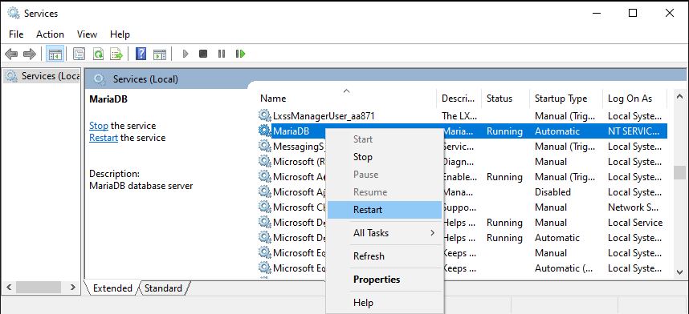

* care needs to be taken when modifying this file, the configuration parameters, variables, and their subsequent values must be exact; as well as contain ASCII-compliant characters
* ***Why does it need to be exact?***
* well, once the file is saved, when you restart the service, it may not restart, until you correct the error
* ***How do I know if it didn't start?***
* usually you will get some message though in Services, it has a column that indicates if the program is Running, hit [F5] to refresh the Services list
* ***How do I know if the setting worked?***
* well before any setting is added to this file, you should know how to test it out first...we will get to that

Makes sense that the **my.ini** is in the **DATADIR**, as when backing up databases, this would be critical to have backed up, as well as the **.err** Error Log File.

Before you make changes to the file, best you back it up as **my.ini_YYYYMMDD.bak**, where **YYYYMMDD** is an 8 character date, using zero-padding for single digit Days or Months ( ie: March 1st's MMDD is 0301 ), thus keeping them in sequential order in the directory's file listing with a fixed width file naming convention. Here is an example in File Explorer, noting, it always sorts alphabetically within an alphanumeric naming convention file sort:

...my.ini changes were done 2 December 2019, 1 March 2020, and 28 November 2021.  File naming ordering and fixed width portions within file naming allow for that, ALWAYS follow file conventions that are indicated to use for your assignments, exactly as asked for.

System / Environment Variables

From the [**START**] menu, type in "**system variables**" or "**environment variables**" and hit [**ENTER**].

This opens **System Properties** > **Advanced** tab and within, click on the **Environment Variables…** button.

Under **System Variables,** double click **Path**variable to open its **Edit environment variable** entry window.

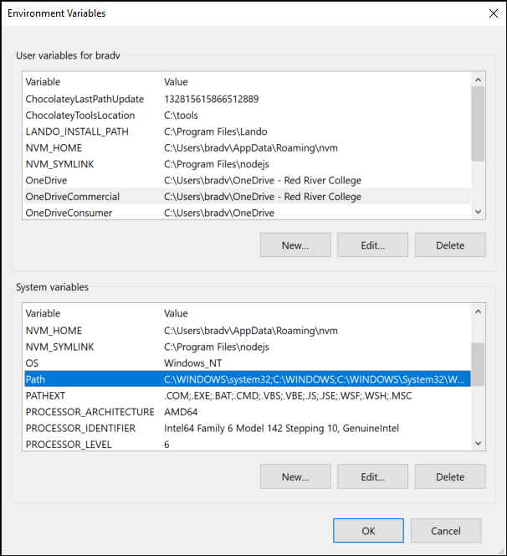

Click **New**, then add the Path to your \bin directory, which is:  
  
**C:\Program Files\MariaDB 10.6\bin**

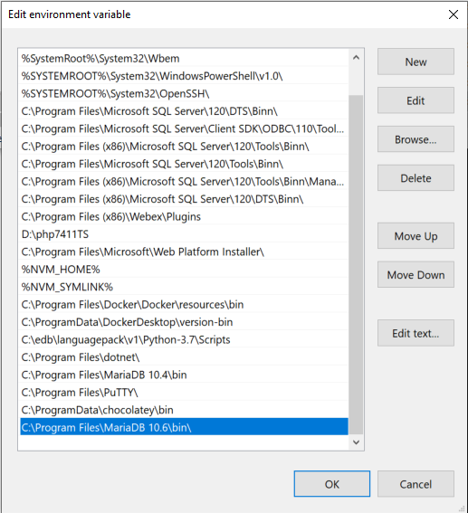

Then click **Ok**, **Ok**, **Ok**.

If you have a **Command Prompt** open, close and reopen it, then type **mysql** and hit [**ENTER**], which should give you an *Access denied error*, though now you can access the **MySQL CLI** from any directory within the command-prompt / terminal.

***Next: Connecting into MySQL CLI and CREATE DATABASE***

## 